***EX.NO:11:- CONFERENCE MANAGEMENT SYSTEM***

USECASE DIAGRAM: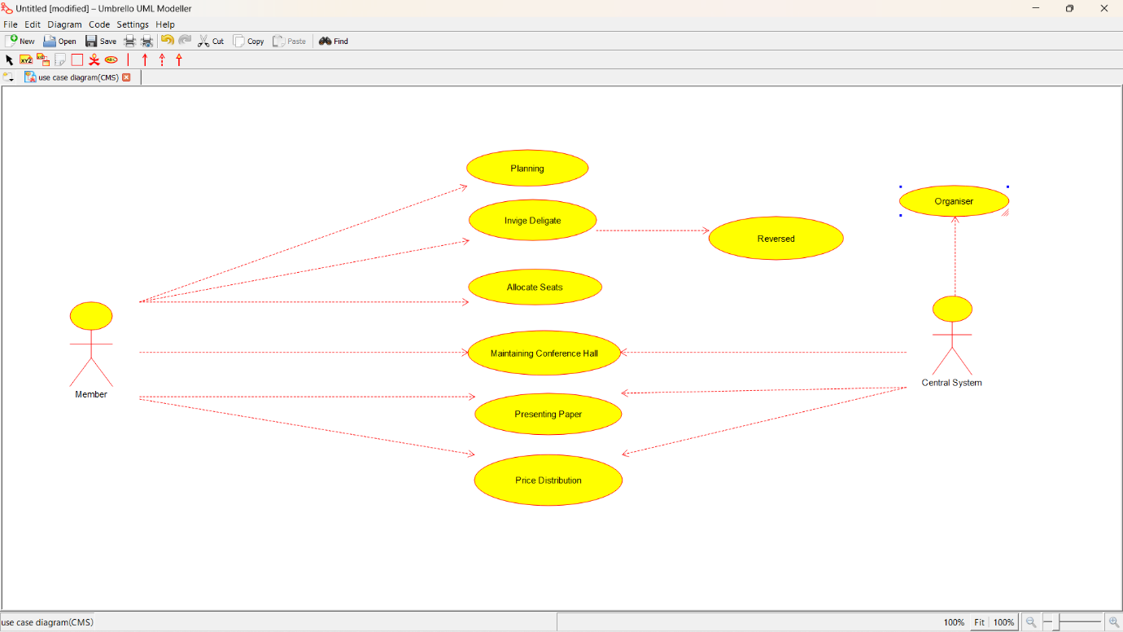

CLASS DIAGRAM:

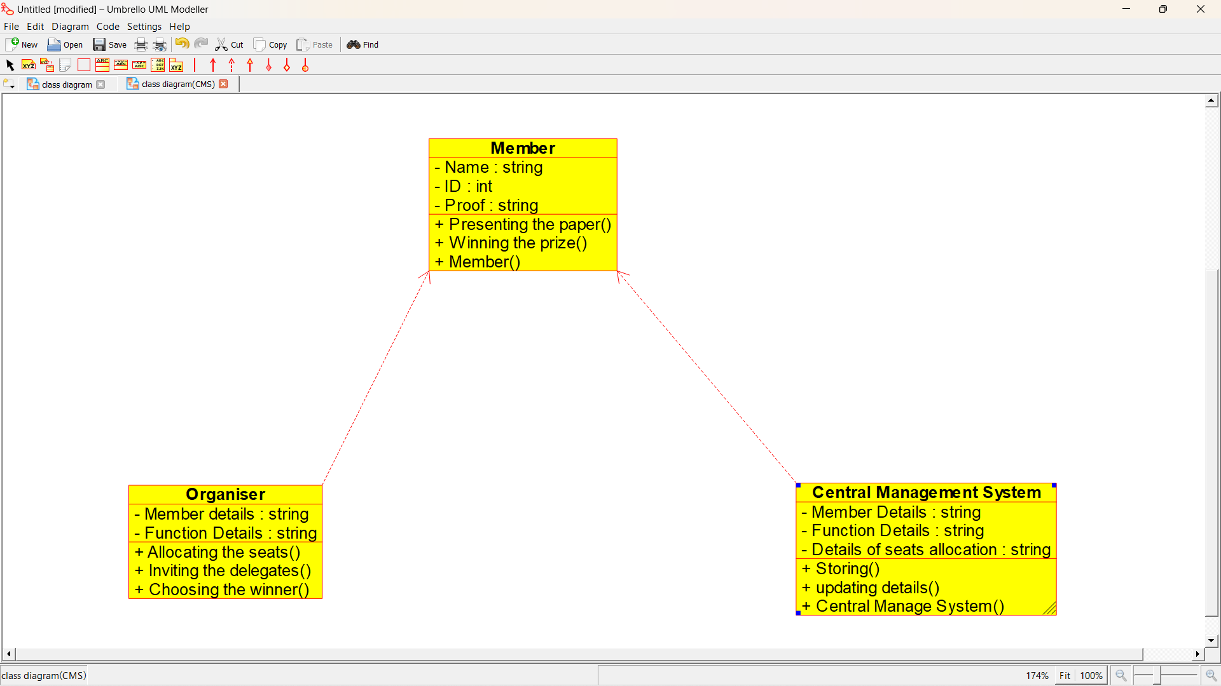

ACTIVITY DIAGRAM:

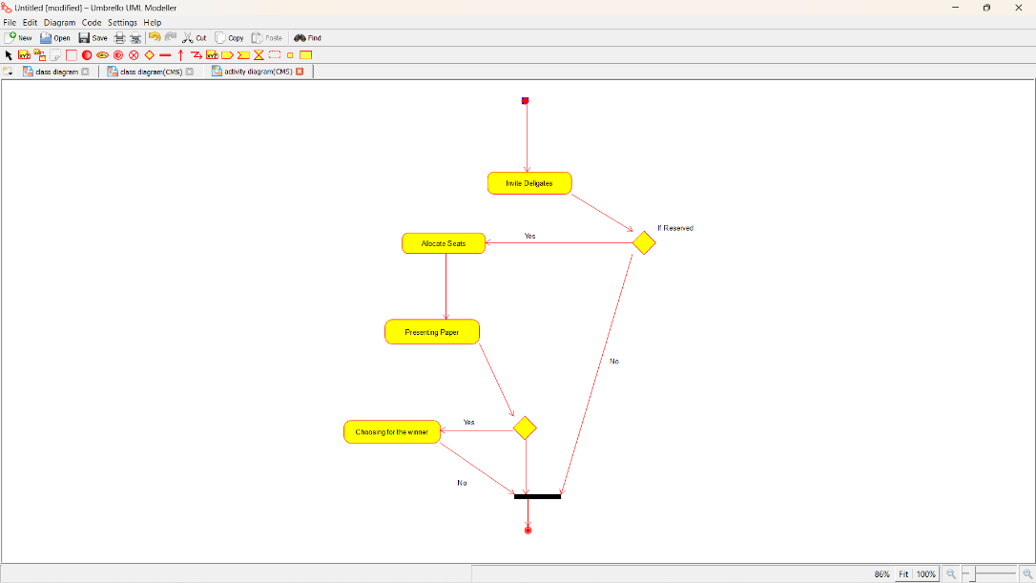

SEQUENCE DIAGRAM:

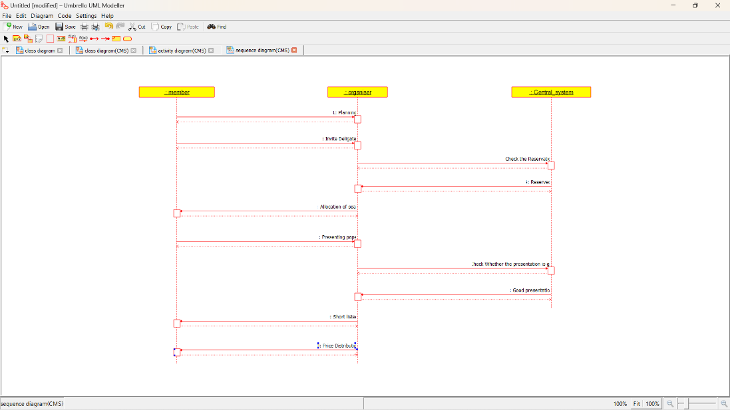

COLLABORATION DIAGRAM:

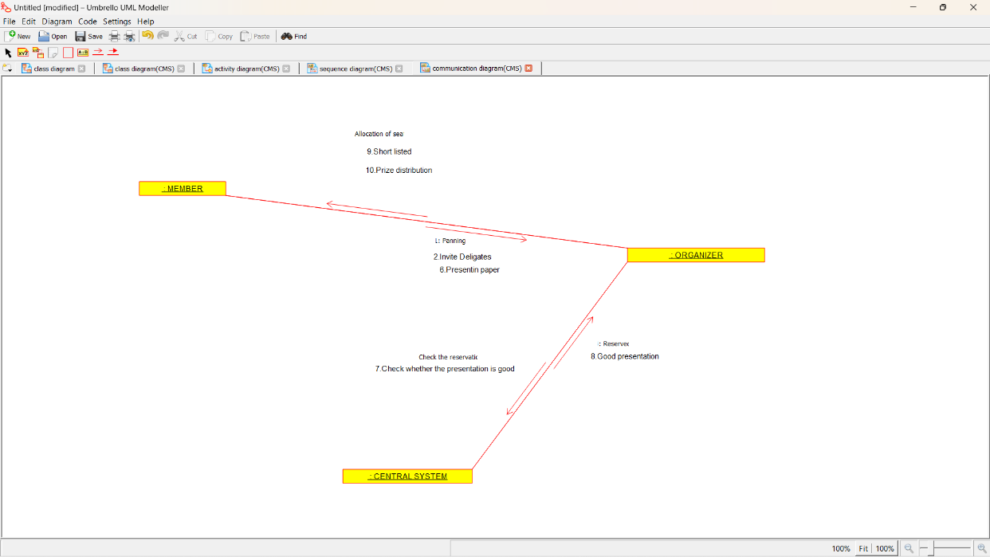

COMPONENT DIAGRAM:

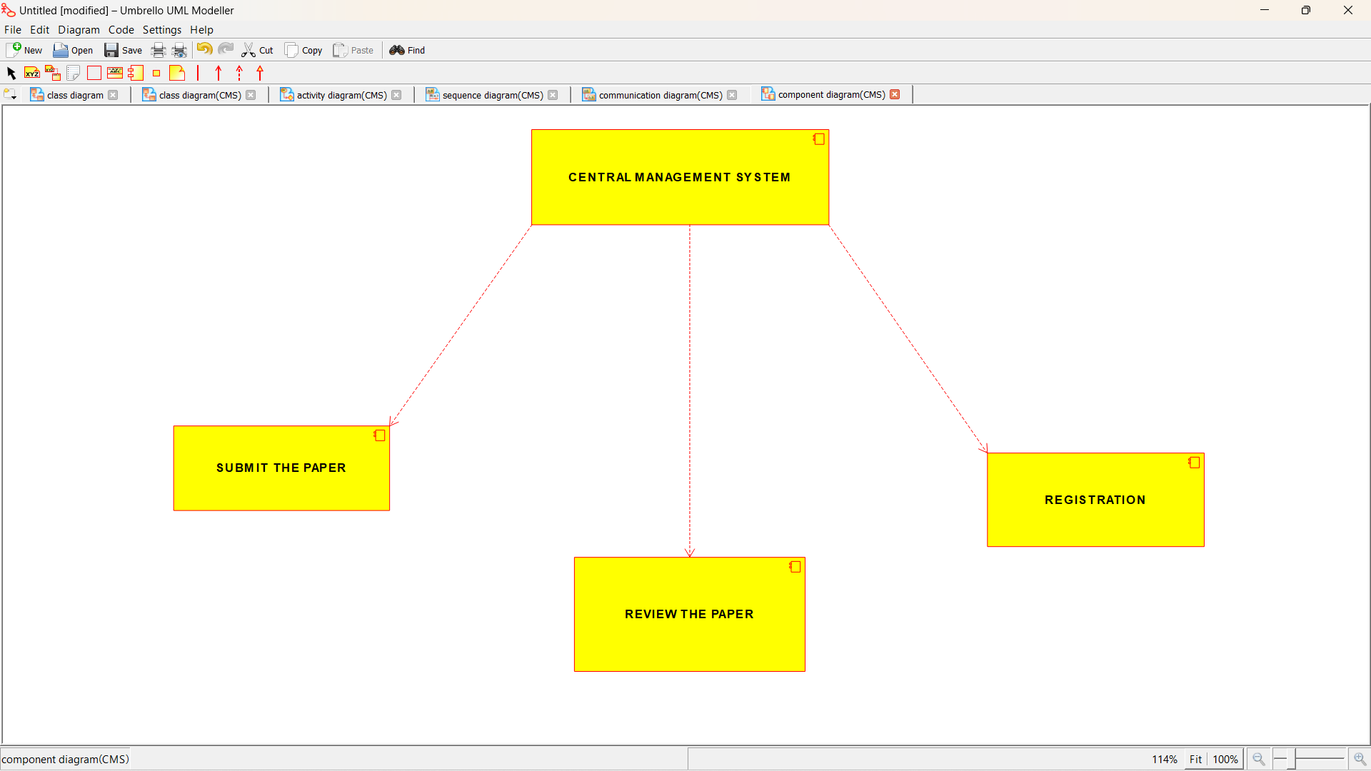

DEPLOYEMENT DIAGRAM:

